Team Project Report

**Team Members**

Deniz Candas, Brian Case, Long Nguyen-Duong, Jeremy Johnson

**Team Model**

Our team has adopted Chief Programmer Model. We believed this model is suitable for our current case where out of class in-person communication is limited. Our team organization and duties are listed as follows;

Deniz Candas – Documentation Assistant

Brian Case – Backend Development

Long Nguyen-Duong – Chief Programmer

Jeremy Johnson – Frontend Development

**Life Cycle Model**

By judging the scope and complexity of the project we have decided a rapid prototype model is suitable for this project.

**UML Diagrams**

**Use Case Diagram**

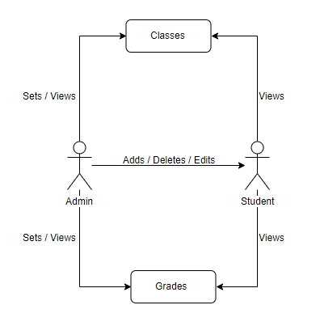

**Architecture Diagram**

